**Aimen Shahzad (FA23-BSE-111)**

**Lab Task 1 :**

**Write a program to print all natural numbers from 1 to n.**

#Write a program to print all natural numbers from 1 to n.

#starting point

x=1

#ending point

n=int(input("enter a number "))

#while loop condition

while x<=n:

#run loop until x is less than 1

     print(x)

#increase value by 1 in every step of loop

     x=x+1

**Results:**

**Lab Task 2**

**Write a program to print all even numbers between 1 to 100.**

#write a program to print all even nos from 1 to 100.

x=0

n=100

while x<n:

    x=x+2

    print(x)

**Results:**

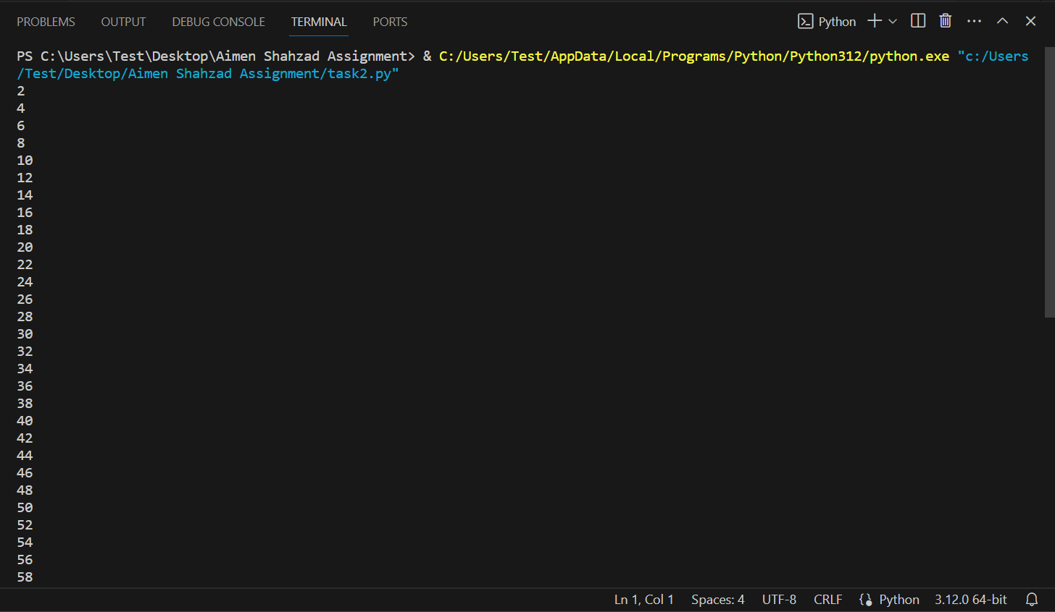

**Lab Task 3:**

**Write a program to ask user input for a number. Check if it is a prime number. If it is, end the program but if it is not ask for the user input again till the user enters a prime number.**

"""Write a program to ask user input for a number. Check if it is a prime number. If it is, end the program

but if it is not ask for the user input again till the user enters a prime number."""

status=True

while status==True:

    is_prime=True

    number=int(input("enter a number "))

    for i in range (2,number):

        if number%i==0:

            is_prime=False

    if is_prime==True:

        print("your number is prime")

        status=False

    else :

        print("your number is not prime")

**Results:**

**Lab Task 4 :**

**Write a program to print a table of numbers from 1 to 8.**

#write a code to print a table

x=int(input("enter a number "))

y=1

while y<=10:

    result=x*y

    y=y+1

    print(x,"x",y,"=",result)

**Results:**

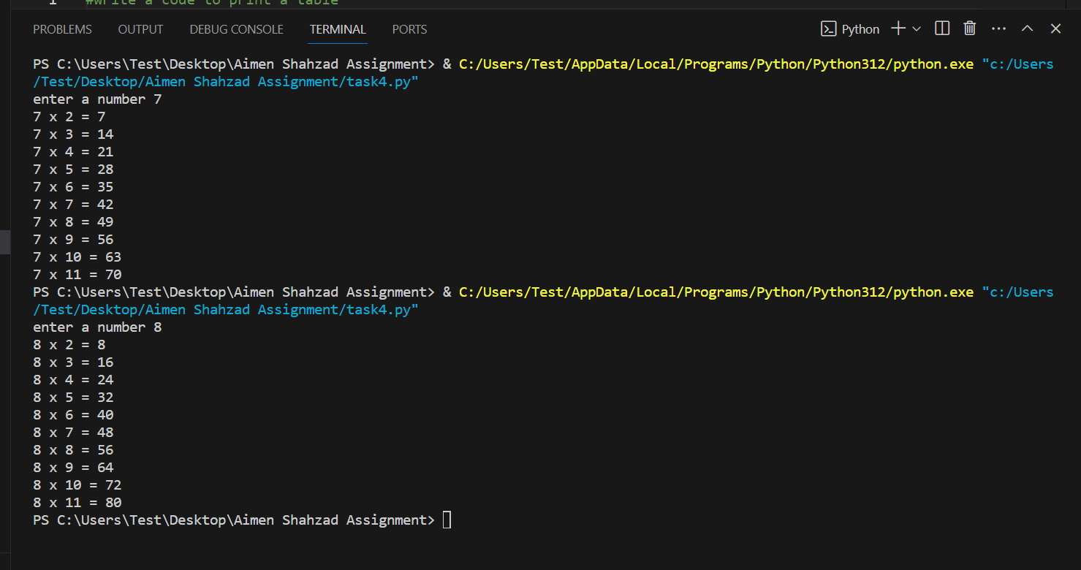

**Lab Task 5 :**

**Write a nested for loop that prints the following output:**

n=3

for y in range(n+1):

#will define number of rows

    for x in range(n-y):

#will define number of spaces in each row

        print(" ", end=" ")

    for z in range(y):

#will print values of left triangle

        print(2 ** z, end=" ")

    for z in range(y, -1, -1):

#will print values of right triangle

        print(2 ** z, end=" ")

    print()

**Results:**

